**Login Page and Onboarding Process – Sign In Existing Users**

Datamond Kevin - 0250303

Here's a detailed breakdown of a **User Login & Onboarding Page** for your AI accounting platform, considering best practices from **Sage, NetSuite, and QuickBooks**, while aligning with your target clientele:

**1. User Login Page (Existing Users)**

This page serves **existing** users who already have an account.

**Login Page Elements:**

* **Email / Username** field
* **Password** field
* **Remember Me** (checkbox)
* **Forgot Password?** (link)
* **Sign In** (button)
* **Sign in with Google / Microsoft / Apple** (OAuth options)
* **New to the platform? Sign Up Here** (redirect to onboarding)
* **Security Step: Email or SMS Verification**
  + After entering credentials, users receive a **verification code via email or SMS**.
  + A new screen prompts users to **enter the code** before granting access.
  + **"Resend Code"** option if they don’t receive it.
  + Option: **“Remember this device for X days”** to skip this step on trusted devices.
  + A QR Code that can scan: Scan QR Code to log in with
    - MFR Login (Multi-Factor Registration, for additional security verification)
    - Passwordless Authentication (MFA) (Log in without a password using Multi-Factor Authentication, such as OTP, Face ID, or fingerprint scan)
    - Notify My Employer (Automatically inform your employer that you've registered for access to the platform)

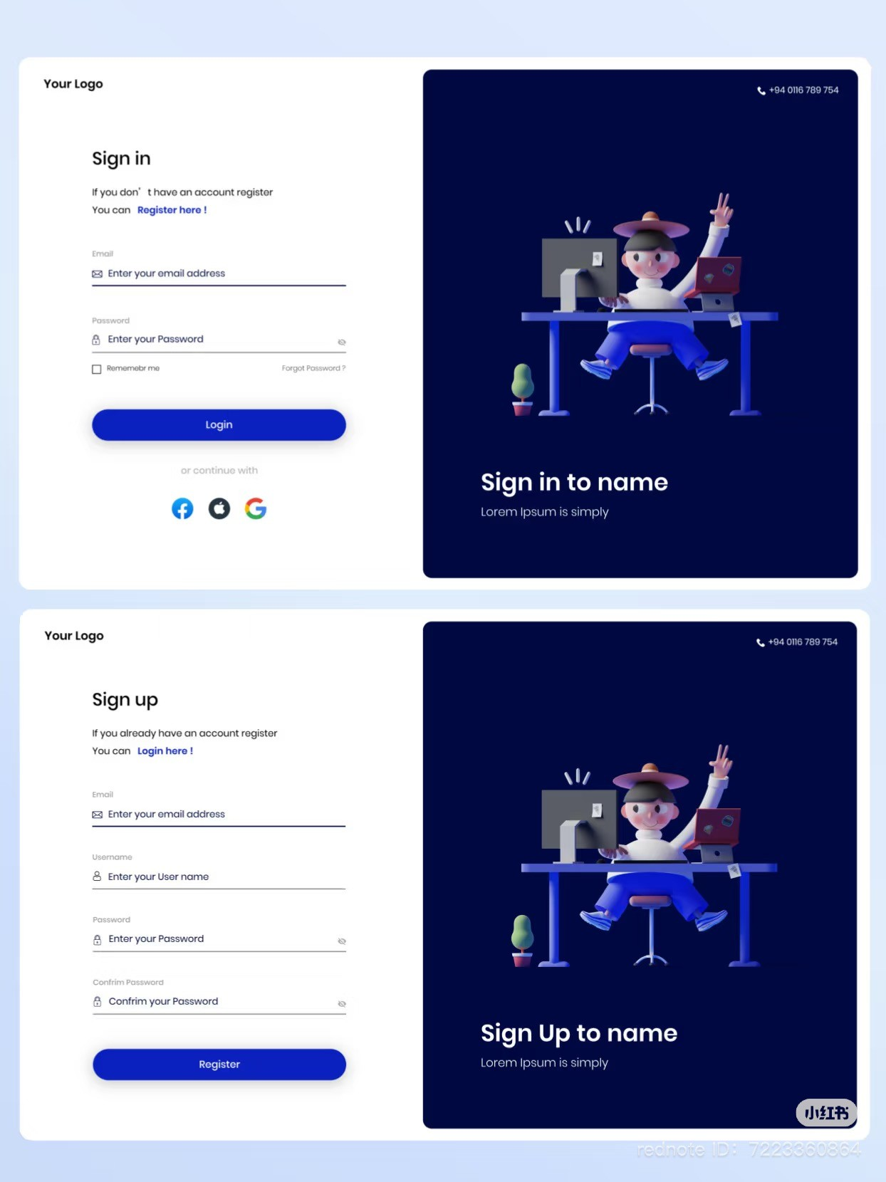

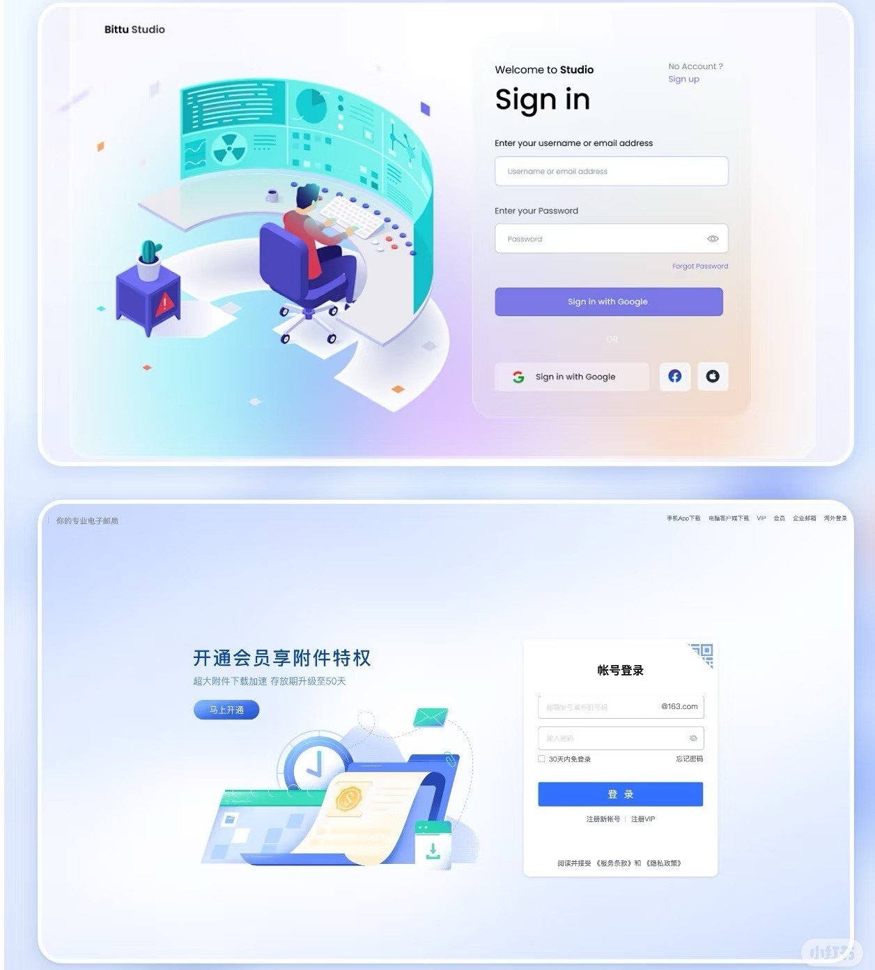

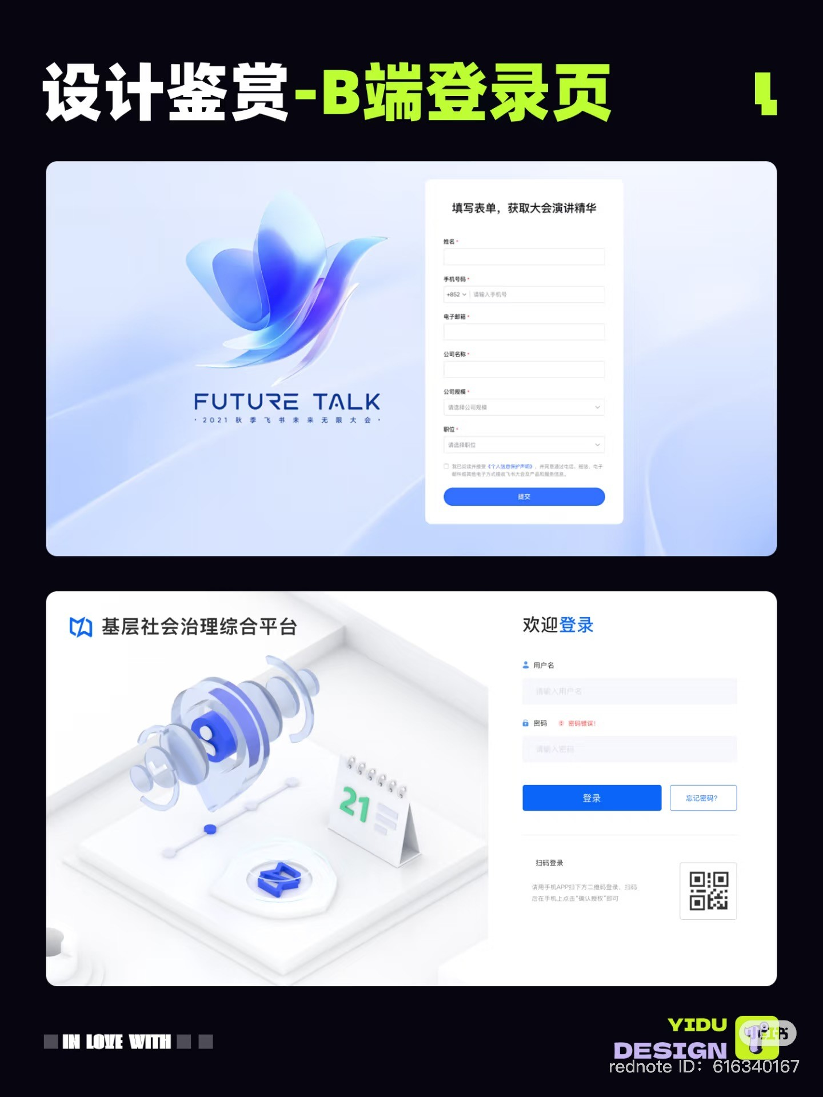

Here’s the **wireframe** for the **User Login Page (Existing Users)** with the requested features:

**Sections Included:**

1️. **Login Page**

* **Email / Username** & **Password fields**
* **Remember Me** checkbox & **Forgot Password?** link
* **Sign In button**
* **OAuth sign-in options** (Google, Microsoft, Apple)
* **New User? Sign Up Here** (redirect to onboarding)

2️. **Security Verification (After Login)**

* Users receive a **verification code via email or SMS**
* **Enter Verification Code field** with **Resend Code option**
* **Remember this device for 30 days** checkbox

3️. **QR Code Authentication (Alternative Login)**

* **Scan QR Code to Log in with:**
  + **MFR Login (Multi-Factor Registration)**
  + **Passwordless Authentication (MFA)**
  + **Notify My Employer**

